Visualizations in ArcGIS Pro – Learning basic tools and how to visualize spatial data

In this tutorial you are going to become familiar with some basic tools used in the ArcGIS environment to help organize and manipulate your data allowing for initial spatial data exploration. Then you will learn how to visualize the spatial data by understanding how to use colors, change the graphic elements on the map, and exploring data visualization over different categories and numeric scales. We are going to be working with data from Dr. John Snow’s famous Cholera outbreak map. Read some background information about this event here: <https://www.ph.ucla.edu/epi/snow/snowcricketarticle.html>.

**OBJECTIVES**

* **Open an ArcGIS Pro project file**
* Spatial join
* **Creating a buffer**
* **Changing symbol graphic elements**
* Graduated symbols
* Choropleth maps
* Creating a heat map

Requirements:

1. Data included in the map project file (same as exercise 1). Sources:
   1. Cholera deaths and water pumps (Point data): <https://kuscholarworks.ku.edu/handle/1808/10772>
   2. Road and place boundary shapefiles for the Greater London Area (Line and polygon data): <http://download.geofabrik.de/europe/great-britain/england/greater-london.html>
   3. Polling districts for the Greater London Area (Polygon data): <https://osdatahub.os.uk/downloads/open/BoundaryLine>
   4. John Snow’s Original Map Georeferenced (Raster data): <https://github.com/mapninja/ArcGIS-Pro-101/tree/master>

Section 1: Learning Basic Tools

## Section 1.1: Open an ArcGIS Pro project

In the last exercise, you learned how to save an ArcGIS Pro project. This allows you to be able to readily open a map you have previously worked on and view, make edits, or share it.

For the first part of this tutorial, you will learn how to open the ArcGIS Pro project.

1. Open ArcGIS Pro on your desktop, and make sure that you are signed into your ArcGIS Pro profile. If the project is one that you have recently worked on, you will see the name of it under **Recent Projects**. If not, you can click **Open another project**.

1. After clicking **Open another project**, a pop-up window will appear. Navigate to your tutorial data folder and select **JohnSnow.aprx** and click **OK**.

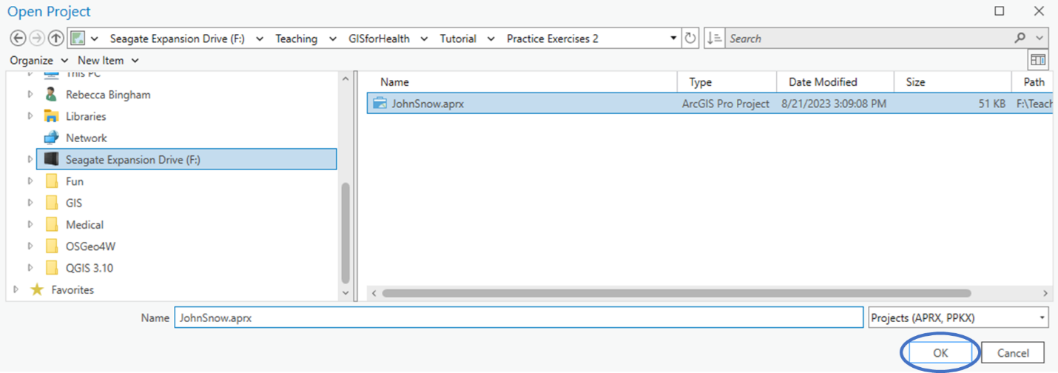

1. Once you have finished this, the software will open the **JohnSnow.aprx** mapping project, which contains four GIS vector layers over an OpenStreetMap basemap.

**Section 1.1 Task:** Submit a screenshot of the open map project on ArcGIS Pro.

## Section 1.2: Spatial join

In some cases, you want to understand how one GIS layer relates to another spatially. For instance, if you want to understand what county a specific building is in or what road is closest to a certain point. You can assign these features to that building or road using a spatial join. The **Spatial Join** tool will match the rows from a join feature to a target feature based on their relative spatial locations.

For this part of this tutorial, you will learn how to use the spatial join tool.

1. Right click the **CholeraDeaths** layer and hover over **Joins and Relates**. Select **Add Spatial Join**.

1. After clicking **Add Spatial Join**, a pop-up window will appear. Click the drop-down arrow under **Join Features** and select **WaterPumps**. For **Match Option**, use the drop-down arrow to select **Closest**. Keep all other options as default and click **OK**.

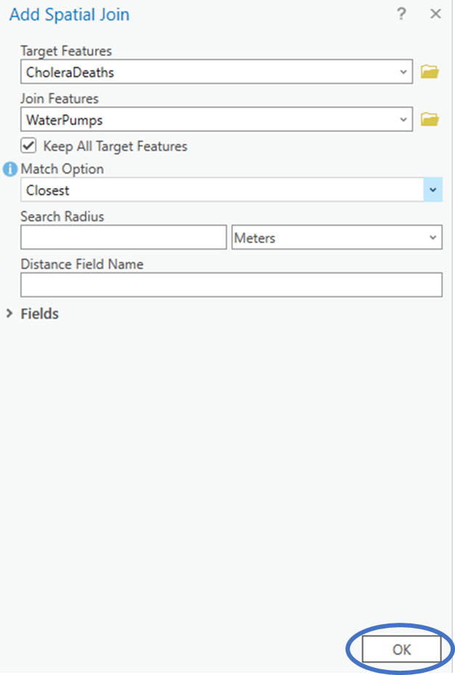

1. Once you have finished this, each feature in **CholeraDeaths** will be assigned the water pump that is within the closest distance to the point location.

**Section 1.2 Task:** Submit a screenshot of **CholeraDeaths** attribute table with the assigned features from **WaterPumps**.

## Section 1.3: Creating a Buffer

In some cases, you want to know what study locations are located within a certain distance of a specific point. The **Buffer** tool will create polygons around a specific point, line, or polygon to a specified distance around the area. This will allow for easy extraction of study locations within these polygon buffers.

For this part of this tutorial, you will learn how to use the buffer tool.

1. Along the top of your ArcGIS Pro environment, click **Analysis**.Then choose **Pairwise Buffer**.

1. After clicking **Pairwise Buffer**, a pop-up window will appear at the right of your ArcGIS Pro environment. Click the drop-down arrow under **Input Features** and select **WaterPumps**. For **Output Feature Class**, click the folder next to the text box and navigate to the **JohnSnow.gdb** geodatabase. Name the new feature class **WaterPumps_Buffer** and click **Save**.

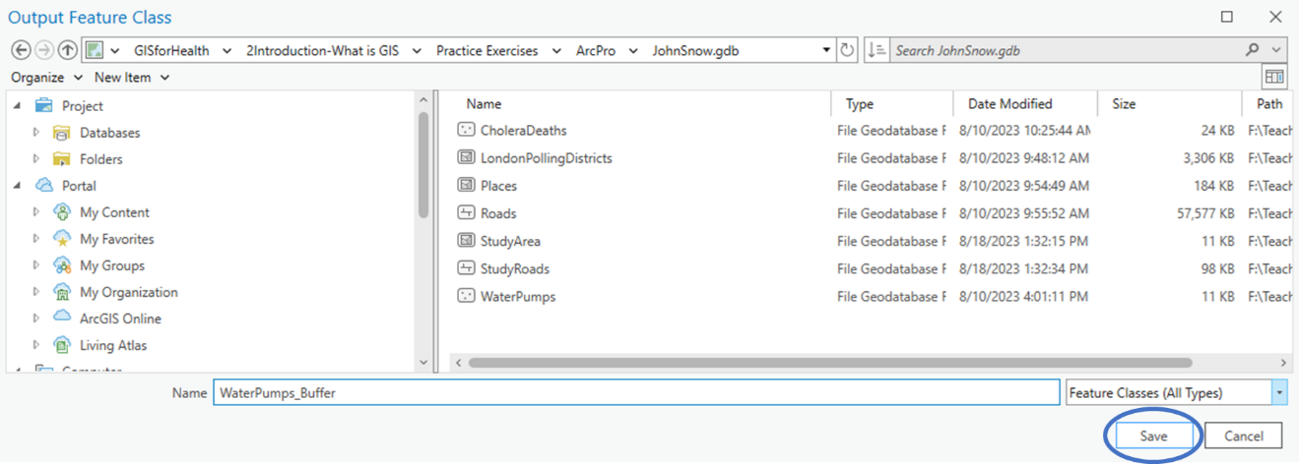

1. Continuing in the pop-up window on the right side of the ArcGIS Pro environment, there is a text box under **Distance**. In this text box, enter **250**. The input box next to the text box in which you entered 250, click the drop-down arrow and choose **US Survey Yards**. Keep all other options as default and click **Run**.

1. Once you have finished this, the new polygon feature called **WaterPumps_Buffer** will automatically be added to your map showing circles with a 250 yard radius around each water pump in the study area.

**Section 1.3 Task:** Submit a screenshot of your map **WaterPumps_Buffer** layer included.

## Section 1.4: Changing Symbol Graphic Elements

Using the same symbol type for the same kind of features (i.e., circles for point locations) can make the map difficult to read, even if you use different colors. You can change the symbol’s graphic element to make it easier to differentiate different types of features of the same kind.

For this part of this tutorial, you will learn how to change the graphic elements for point and line symbols.

1. In this exercise, we have point locations which include water pumps that service the study area (**WaterPumps**) along with point locations that symbolize where deaths occurred because of the cholera outbreak (**CholeraDeaths**). We want to change the graphic elements of the **WaterPumps** symbols to better identify the difference between these point locations. First, click the symbol below **WaterPumps** in the **Contents** pane on the left side of your ArcGIS Pro environment.

1. After clicking the symbol, a pop-up window will appear at the right of your ArcGIS Pro environment. In this pop-up window, click the symbol next to the word **Symbol**. In the search bar, type **water**. Search for the **Droplet** symbol under the **ArcGIS 2D** section and choose it.

1. This changed all the features in the **WaterPump** layer to black water droplets. We want to change the color of these symbols to blue. In the **Symbology** pop-up window on the right side of the ArcGIS Pro environment, click **Properties**. Choose the drop-down arrow next to the color and select **Cretan Blue**. Click **Apply**.

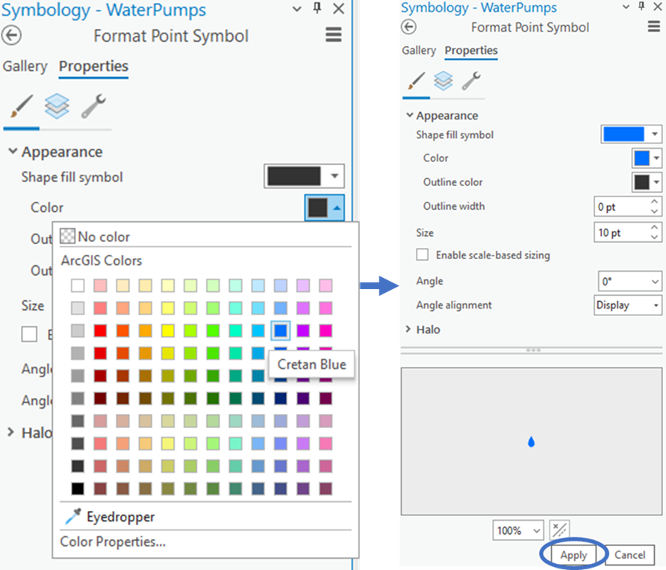

1. Changing the graphic elements for line features uses the same steps. First, click on the symbol below the **StudyRoads** layer in the **Contents** pane on the left side of the ArcGIS Pro environment. Then, click **Gallery** at the top the pop-up box on the right side of the ArcGIS Pro environment. Since these are just residential streets, choose the **Minor Road** symbol along the top line of choices.

**Section 1.4 Task:** Submit a screenshot of your map showing the new symbols for the point and line features with the **WaterPumps_Buffer** layer deselected for better viewing.

# Section 2: How to Visualize Spatial Data

## Section 2.1: Graduated Symbols

When visualizing data, we can observe that some locations might have higher rates or frequencies than others, which can be stored in the attribute information. In our exercise, the **CholeraDeaths** point locations stores the number of cholera deaths at each point. Individuals can better visualize this information if we use graduated symbols. This will make areas with higher rates or frequencies have larger symbols.

This part of the tutorial will demonstrate how to create graduated symbols on your map.

1. Continuing in the **JohnSnow.aprx**, click the symbol under the **CholeraDeaths** layer in the **Contents** pane on the left side of the ArcGIS Pro environment. If needed, click the back arrow at the top the pop-up box on the right side of the ArcGIS Pro environment. Under **Primary symbology**, click the drop-down arrow next to **Single Symbol** and select **Graduated Symbols**.

1. This changes the pop-up window to having a new form to fill out. Next to **Field** choose **DEATHS**. Next to **Template**, click the symbol. At the top of the pane, choose **Properties**. Click the drop-down arrow next to the **Color** and choose **Tuscan Red** and click **Apply**.

1. Click the back arrow at the top the pop-up box on the right side of the ArcGIS Pro environment. Keep all other information the same, and the form in the **Symbology** pane will now look like the figure below.

**Section 2.1 Task:** Submit a screenshot of your map on ArcGIS Pro with the graduated symbols.

## Section 2.2: Choropleth maps

You can also view different rates or frequencies using varying shades of color. This is called a **Choropleth Map**. This is usually done with polygons, but in this case, we are going to do it for point locations. The steps to change the symbology are the basically same for both types of features.

This part of the tutorial will demonstrate how to create choropleth maps.

1. Because the **Symbology** pane is already open for **CholeraDeaths**, you can work from there. Click the drop-down arrow under the **Primary symbology** and choose **Graduated Colors**. Next to **Field** choose **DEATHS**. Next to **Color Scheme**, click the drop-down arrow and choose **Reds (5 classes)**.

1. Keep all other information the same, and the form in the **Symbology** pane will now look like the figure below.

**Section 2.2 Task:** Submit a screenshot of your map on ArcGIS Pro with the graduated colors.

## Section 2.3: Creating a heat map

We can use point layers to calculate relative density and display it easily on a map. This could be helpful to quickly visualize the highest rates or greatest frequencies in a specific area. Rates and frequencies can then be outlined in contours of different shading to demonstrate higher and lower occurrences. This is called a **Heat Map.**

This part of the tutorial will demonstrate how to create a heat map using the John Snow data.

1. This process is similar to changing symbologies. We will continue in the **Symbology** pane using the **CholeraDeaths** layer. Click the drop-down arrow under the **Primary symbology** and choose **Heat Map**. Next to **Weight Field** choose **DEATHS**. Keep everything else the same.

1. The result will show areas with the highest number of deaths in yellow, lowering into orange, then red, followed by purple, then blue, with areas with no deaths transparent. If you notice, there is one water pump in particular in the yellow area. If you click on this pump, it will tell you its name.

**Section 2.3 Task:** Submit a screenshot of your heat map on ArcGIS and answer the following question:

**What is the name of the water pump in the yellow area of the heat map?**